Bonita Council to decide on the future of Revana Lakes
- BY SHELDON ZOLDAN
- JULY 12, 2024
- PHOTO CREDIT:SEAGATE DEVELOPMENT GROUP

PLAY ARTICLE
3 min
PLAY ARTICLE
3 min
Bonita Springs City Council will decide the future of a planned upscale community along Bonita Beach Road after the city’s planning agency recommended against it.
Seagate Development Group, developers of Revana Lakes, made a presentation this week to about 15 Bonita Springs residents, hoping to allay their fears concerning the project. It was the fourth presentation to neighbors of the proposed development.
James Nulf, a Seagate partner, told those attending the development was “a crown jewel.” The project is different than many of the cookie-cutter gated communities being built in Southwest Florida.
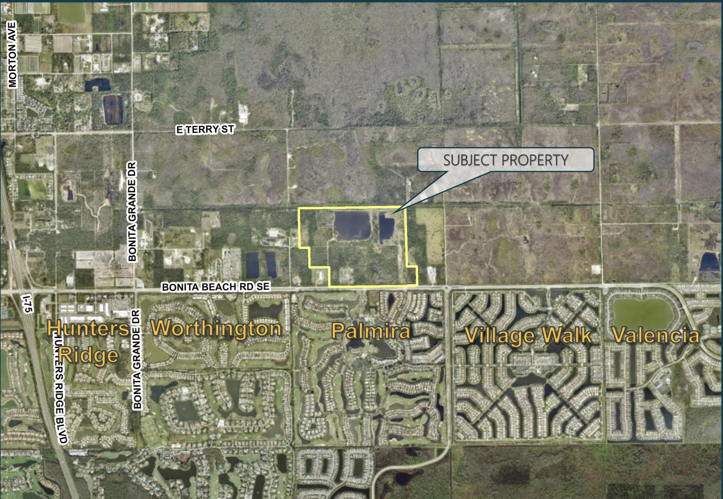Seagate plans to build 299 units, most of them high-end single-family homes starting at about $2 million, on 204 acres on the northside of Bonita Beach Road across from Palmira Country Club and Village Walk.
The project includes 30,000 square feet of commercial space with the kind of stores that will serve people in the community, so they won’t add to the traffic on Bonita Beach Road, Seagate officials said.
ADVERTISING
Seagate purchased the property in 2020. About 114 acres were annexed into Bonita Springs in 2008 and 90 remain in Lee County.
Seagate wants Bonita to annex the remaining 90 acres and to designate the community as an Urban Fringe Community District, which allows residential and limited community use. It also is asking for a portion to be designated as Resource Protection.
The land now is part of Lee County’s Density Reduction/Groundwater Recharge designation. The annexed portion was never rezoned and remains under the county’s DR/GR category.
The DR/GR category only would allow 14 homes to be built on the site. The change would allow up to 552 units, but Seagate’s plans call for 388.
The developer cut the number to 299 after the city’s Local Planning Agency unanimously rejected the project at its May 16 meeting.
City staff made no recommendation at the meeting. Senior Planner Mike Fiigon said it should be up to Council because changing the designation to an Urban Fringe Community District is a major policy decision.
About a dozen residents living in developments along Bonita Beach Road spoke against the project during the May meeting. Most of the complaints were about traffic, with concerns about wildlife, water runoff and density sprinkled in.
The developers were surprised by the vote, said Alexis Crespo, vice president of planning for RVi Planning, the planning consultant on the project.
“We had positive neighborhood meetings,” she said. “We were surprised so many people showed up.”
More than a dozen people spoke at the LPA meeting.
The dozen residents who attended this week’s presentation were mostly satisfied with the plans.
The project goes to Council for the first time during a public hearing Aug. 7.
“It’s going to be an interesting meeting to say the least,” council member Laura Carr said.
Seagate said construction would begin in mid-2025 if the city approves the project. Nulf expects the project to take about eight years to complete with about 30 homes constructed a year.
Seagate could turn to Lee County if Bonita turns down the project. The developer, however, hasn’t discussed the option, Crespo said.

